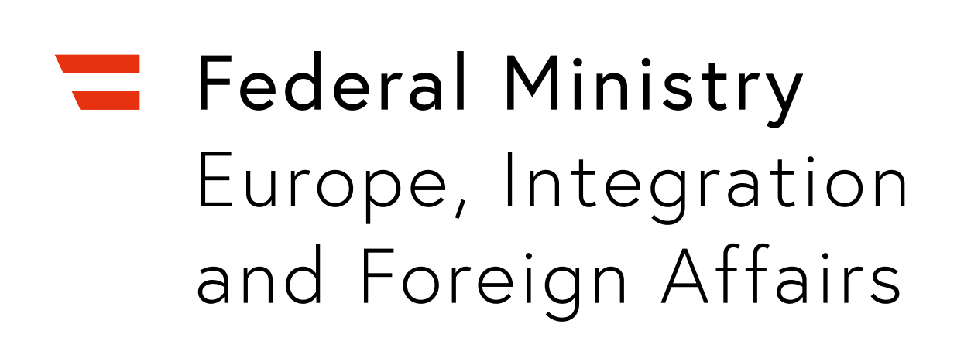

Category INNOVATION

Dear applicant! Please fill in all of the questions below. We can only consider completely filled in forms. All questions must be answered in either English, French or German. Kindly note the maximum amount of characters and do not exceed this limit.

Please submit this form no later than 30th of April 2019 via e-mail to dialogue@bmeia.gv.at and attach max. two good quality photos illustrating your project’s work and/or team. Photos allow us to get a clearer impression of your activity and are a vital part of your application.

When submitting your application, please make sure to indicate “Application – IAA – [Your country of application]” in the subject heading of your e-mail. Our team wishes you the best of luck!

(1) Applicant Information

Surname: Given Name:

……………………………………………… ………………………………………………

Street and Number: Postal Code and City:

……………………………………………… ………………………………………………

Province/Country: Telephone (incl. country code, i. e. +43)

……………………………………………… ………………………………………………

E-mail: Applicant’s position within the organisation

……………………………………………… ………………………………………………

(2) The Organisation (if applicable)

Name of the organisation: Type of organisation:

……………………………………………… ………………………………………………

Main field of activity: No. of employees/volunteers:

……………………………………………… ………………………………………………

Established: (dd/mm/yyyy) Website (if applicable):

……………………………………………… ………………………………………………

Location (street, number, city): Other social media (if applicable):

……………………………………………… ………………………………………………

How did you hear about this award? Name of Managing Director:

……………………………………………… ………………………………………………

(3) The Project

Title/name of project:

………………………………………………………………………………………………………………………

You are engaged in intercultural dialogue. Which of the IAA’s thematic priorities apply to your project? Please specify: Art/Culture – Youth – Human Rights – Global Citizenship Education

………………………………………………………………………………………………………………………

Operative since: (dd/mm/yyyy) Total duration of project/project cycle: (in months)

………………………………………… ……………………………………………………………………

Describe the project in one sentence: (max. 200 characters)

………………………………………………………………………………………………………………………

………………………………………………………………………………………………………………………

………………………………………………………………………………………………………………………

Description of project: (max. one page)

Please describe in a concise manner. We can only accept applications that do not exceed the given limit. In your description, kindly answer the following questions or include the following information (obligatory!):
- How does your project promote intercultural dialogue? What does intercultural dialogue mean to you?
- Please indicate your target group and all supporters, partners and sponsors of the project. Kindly describe the form and duration of the cooperation.
- Why do you consider your project to be innovative?
- In which context does your project operate? Why is it necessary? Which challenges does it respond to? What are the main activities and outcome of the project?
- How would you use the prize money?

………………………………………………………………………………………………………………………

………………………………………………………………………………………………………………………

………………………………………………………………………………………………………………………

………………………………………………………………………………………………………………………

………………………………………………………………………………………………………………………

………………………………………………………………………………………………………………………

………………………………………………………………………………………………………………………

………………………………………………………………………………………………………………………

………………………………………………………………………………………………………………………

………………………………………………………………………………………………………………………

………………………………………………………………………………………………………………………

………………………………………………………………………………………………………………………

………………………………………………………………………………………………………………………

………………………………………………………………………………………………………………………

………………………………………………………………………………………………………………………

………………………………………………………………………………………………………………………

………………………………………………………………………………………………………………………

………………………………………………………………………………………………………………………

(4) Declaration of consent

I hereby confirm that the information provided in this application is accurate and true.

I hereby confirm that the applying organisation fulfils the local legal requirements and conditions and thus holds the right to operate the project submitted to this competition.

I hereby declare that I am authorised to submit this application on behalf of the respective organisation.

I hereby agree that the information provided in this application may be used by the Austrian Federal Ministry for Europe, Integration and Foreign Affairs; by Austrian representations abroad; as well as by cooperation partners to promote the project and its participants through social media information material.

In case of selection for a prize, I consent that information relating to myself, the project and the organisation may be published on the website of the Austrian Federal Ministry for Europe, Integration and Foreign Affairs at bmeia.gv.at as well as in other digital and print media outlets, including those of cooperative partners.

My consent to use the information provided by me can be retracted at any time. This will be considered a withdrawal from the contest. Please contact dialogue@bmeia.gv.at for further information.

Information will be used for the above-mentioned activities only. The transfer of information to third parties, other than cooperative partners, will not be undertaken without prior approval from the applicant.

Please make sure that you have filled in all relevant information before signing and submitting your application. Please also note that in case of pre-selection, you might be asked for additional documentation about your project.

Kindly submit your complete application no later than 30th of April 2019!
If you experience any technical difficulties, please contact us at dialogue@bmeia.gv.at.

Please indicate the country of origin of the project/organisation of the country that you are applying from:

………………………………………………………………………………………………………………………

Date: (dd/mm/yyyy) Signature: (please type in your name)

……………………………………………… ………………………………………………

Non-governmental organisation, association/foundation, charitable/educational institution, religious organisation, or commercial organisation.

